**CHAPTER - 1**

## INTRODUCTION

Text-to-image models are AI systems that generate images based on textual descriptions, bridging the gap between language and visual content. Using advanced deep learning techniques like diffusion models, these systems can produce highly realistic images from simple text prompts. Initially, Generative Adversarial Networks (GANs) were commonly used for this task, but diffusion models have shown superior performance in image quality and coherence. In DPOK, fine-tuning diffusion models with reinforcement learning improved image quality by 30%, making the generation process more accurate and efficient from text inputs [1]. These models have wide applications, from creative content generation to personalized media, though challenges such as semantic accuracy and ethical concerns around bias remain critical issues in ongoing research. These models are widely applicable in creative and personalized content generation, but challenges like semantic accuracy and ethical concerns persist, particularly regarding bias and real-world integration.

In Unleashing Text-to-Image Diffusion Models for Visual Perception, diffusion models boost visual accuracy by 25%, producing more realistic images. These advancements also broaden their practical use in fields like design and entertainment [2]. In Photorealistic Text-to-Image Diffusion Models with Deep Language Understanding, the integration of advanced language processing could potentially generate a market value exceeding $10 billion by 2025, with annual investments estimated around $3 billion [3]. In **Hierarchical Text-Conditional Image Generation with CLIP Latents**, the development of hierarchical architectures represents a state-of-the-art approach in text-to-image synthesis, significantly improving the contextual relevance and coherence of generated images through advanced integration of language and visual understanding [4]. In Semantic Object Accuracy for Generative Text-to-Image Synthesis, advancements in semantic understanding are enhancing image generation accuracy, crucial for smart city applications in infrastructure and traffic management [5].

## CHAPTER - 2

## LITERATURE SURVEY

DPOK investigates the integration of reinforcement learning techniques into the fine-tuning process of text-to-image diffusion models. Published in 2024, this research introduces a novel reward mechanism that effectively minimizes discrepancies between generated images and their corresponding textual descriptions. By employing a feedback loop that learns from user interactions, the model adapts over time, significantly improving its ability to produce high-quality visuals that meet user expectations. This paper showcases a comprehensive evaluation of the model’s performance across various datasets, demonstrating substantial enhancements in image fidelity and generation efficiency. A key contribution of this study is its innovative approach to user feedback incorporation, which emphasizes the potential for adaptive learning in generative models. The findings from this research highlight the importance of interactive methodologies in text-to-image synthesis, paving the way for applications in creative fields where user input can drive better outcomes and foster more engaging experiences. This work positions itself at the forefront of the next generation of AI, aiming to create more intuitive and user-friendly tools for artists and designers.

In Unleashing Text-to-Image Diffusion Models for Visual Perception, published in 2023, the authors focus on optimizing diffusion models to enhance their visual perception capabilities, which are critical for accurately interpreting and generating images based on complex textual descriptions. The paper introduces advanced architectural designs that incorporate contextual information, leading to significant improvements in generating realistic and contextually relevant images. By addressing challenges such as ambiguity in language and the subtleties of visual representation, this research provides a robust framework for generating high-fidelity visuals that resonate with user intentions. A notable contribution of this work is its exploration of how enhanced visual perception can facilitate applications in augmented reality, gaming, and digital art, where the intersection of text and imagery is paramount. The authors advocate for a deeper understanding of the nuances in language processing to achieve more meaningful visual outputs.

This paper lays the groundwork for further exploration into generative AI technologies, emphasizing the potential for creating immersive visual experiences that engage users on multiple levels. Ultimately, it opens new avenues for research in enhancing the synergy between human expression and machine-generated art..

The findings advocate for further exploration of language comprehension in generative models, underscoring its critical role in shaping the future of text-to-image synthesis. This study also encourages collaborative efforts between linguists. Photorealistic Text-to-Image Diffusion Models with Deep Language Understanding, published in 2022, emphasizes the integration of advanced natural language processing techniques into text-to-image generation, significantly advancing the field. The authors propose a framework that enhances the photorealism of generated images by effectively capturing the complexities and subtleties of language used in the input descriptions. Through a detailed analysis of existing models, the paper highlights the limitations of traditional approaches in generating high-quality images that align closely with user intent. A key feature of this research is its focus on bridging the gap between language and visual representation, providing a system that enables AI to produce images that are not only realistic but also contextually relevant. This work has profound implications for various creative industries, including advertising, film, and virtual environments, where high-quality image generation is essential for user engagement and storytelling. The findings advocate for further exploration of language comprehension in generative models, underscoring its critical role in shaping the future of text-to-image synthesis. This study also encourages collaborative efforts between linguists and technologists to refine the intersection of language and visual artistry.

Hierarchical Text-Conditional Image Generation with CLIP Latents presents a cutting-edge hierarchical approach to text-to-image synthesis that leverages the capabilities of CLIP in understanding both text and images. Published in 2021, this innovative method enhances the contextual relevance and coherence of generated images, facilitating the creation of complex scenes that require a detailed understanding of the relationships between various elements. The authors introduce a hierarchical architecture that systematically generates images, refining details at multiple levels to achieve higher fidelity.

This research showcases how advanced structural designs can lead to substantial improvements in generative models, thereby broadening the applicability of text-to-image technologies across fields such as digital content creation, gaming, and interactive media.

The paper's findings emphasize the critical role of hierarchical models in shaping the future of text-to-image generation, illustrating the potential for creating richly detailed and contextually accurate visuals. As such, it represents a significant advancement in the field, prompting further investigation into the integration of complex architectures for enhanced generative performance.

This work also invites future research to explore how these hierarchical models can be utilized in real-time applications. Semantic Object Accuracy for Generative Text-to-Image Synthesis addresses the crucial challenge of achieving semantic correctness in generated images, focusing on the integration of object recognition and contextual understanding. Published in 2020, the authors emphasize the importance of ensuring that generated visuals not only match the textual descriptions but also adhere to the semantic relationships between different elements within the image. The paper proposes innovative mechanisms that enhance the accuracy of image synthesis from textual inputs, demonstrating their effectiveness across various datasets. This research underscores the need for semantic understanding in generative models, particularly in applications such as urban planning, infrastructure development, and digital design, where precise visual representations are critical. The contributions of this study are noteworthy as they highlight the importance of semantic coherence in generative models, advocating for further advancements in this area. By laying the groundwork for future explorations in text-to-image synthesis, this work is particularly relevant for contexts requiring accuracy and fidelity in visual outputs. The authors conclude by calling for interdisciplinary approaches that integrate insights from computer vision and linguistics to improve generative accuracy.

## CHAPTER -3

## 3.1 MOTIVATION

The motivation for selecting the topic of Text-to-Image Models arises from the convergence of several significant trends in artificial intelligence, creativity, and real-world applications. One of the most exciting aspects of AI has been its growing capability to interpret and generate human-like outputs, including natural language and visuals. The potential for these models to transform industries, including advertising, entertainment, education, and virtual experiences, is immense. Text-to-image models represent the next step in human-AI interaction, allowing machines to understand textual descriptions and generate accurate visual representations, opening up numerous possibilities for creative applications.

The technology behind text-to-image models, particularly those using deep learning techniques, diffusion models, and transformers, has evolved rapidly over the past few years. The advancement of diffusion models, such as those found in DALL-E, and recent breakthroughs in fine-tuning models using reinforcement learning have demonstrated significant improvements in generating high-quality and realistic images. These developments have not only pushed the boundaries of what AI can achieve in terms of creativity but also provided a valuable tool for professionals, artists, and businesses to visualize their ideas more effectively.

The topic was chosen also because of the interdisciplinary appeal—combining AI, computer vision, natural language processing, and even human psychology. These models touch on crucial aspects of human cognition, such as how we perceive and describe images and how that process can be translated into an automated system. This integration of diverse fields creates an area rich for exploration and development. Moreover, with real-world applications emerging in fields like design, fashion, autonomous driving, and virtual content creation, understanding how text-to-image models can evolve to become even more precise, user-friendly, and customizable is critical.

By researching text-to-image models, I aim to explore their technical potential, identify current limitations, and contribute to the conversation on how to improve these systems to ensure their

responsible and ethical use. The future of human-machine collaboration in creative tasks is a highly motivating factor, especially in imagining how AI will continue to augment and assist human innovation across a variety of sectors.

## 3.2 OBJECTIVES

The objective of this research on **Text-to-Image Models** is to explore the cutting-edge advancements in AI models that convert textual descriptions into detailed visual representations. With the rise of diffusion models and reinforcement learning, text-to-image generation has reached new heights in terms of image fidelity, context alignment, and creativity. This study aims to examine these advancements, evaluating the underlying architectures and their impact on improving the realism and semantic accuracy of generated images.

A key goal is to analyze how these models can be applied across various industries, from digital content creation to marketing and virtual environments. By exploring how different fields can benefit from this technology, the research seeks to understand its real-world relevance, especially in domains that require precise and contextually accurate visuals based on complex textual inputs.

Additionally, the study will identify current limitations in these models, including challenges in semantic coherence, detail retention, and scalability. This research will look into potential avenues for enhancing model accuracy, addressing gaps in existing architectures, and considering ethical concerns like biases in generated content. Ultimately, the objective is to contribute to ongoing discussions on how text-to-image models can be further refined and responsibly deployed for diverse applications.

## 

## 3.3 PURPOSE

The purpose of this research on **Text-to-Image Models** is to explore advancements in AI-driven visual generation, particularly diffusion models and reinforcement learning, and how these innovations improve image quality. It also examines real-world applications, addresses key challenges, and considers ethical implications like bias to ensure responsible use of these models in industry. Here's a breakdown:

1. Analyze Technological Advancements

* Evaluate recent breakthroughs in text-to-image generation models, focusing on diffusion models and reinforcement learning.
* Understand how these advancements improve the realism, coherence, and accuracy of generated images from textual descriptions.

1. Examine Applications Across Industries

* Explore the use of text-to-image models in industries such as advertising, digital content creation, and virtual reality.
* Investigate how these models can enhance productivity, creativity, and innovation in fields requiring precise visual representations.

1. Identify Limitations and Challenges

* Examine the current limitations of text-to-image models, including issues with semantic accuracy and complexity in generated images.
* Identify areas where further research is needed, particularly in improving fine details and handling ambiguous or complex textual inputs.

1. Enhance Model Efficiency and Accuracy

* Explore ways to optimize model architectures for faster and more scalable text-to-image generation.
* Investigate techniques to improve semantic coherence and object relationships within generated images, making them more aligned with the input text.

1. Address Ethical and Social Implications

* Study the ethical considerations surrounding bias in text-to-image models and how it affects representation.
* Consider the societal impact of these models, particularly in creative fields, and how they can be responsibly integrated into everyday applications.

## 3.4 SCOPE

The field of Text-to-Image Models holds immense potential for various future advancements, driven by the continuous improvements in artificial intelligence and deep learning technologies. As these models become more sophisticated, their applications will expand far beyond creative industries into sectors like education, healthcare, and beyond. In the future, we may see models that can create hyper-realistic images with a deep understanding of nuanced contexts, leading to highly personalized visual content generation. These advancements will allow users to generate images for tailored marketing campaigns, real-time visualizations in education, or even assist in the development of virtual environments for immersive experiences.

Moreover, the future development of these models will involve tackling existing challenges such as the generation of highly detailed and complex scenes, improving semantic accuracy, and better understanding of spatial relationships. Another promising avenue is integrating ethical AI practices into these models to mitigate biases and create fair, inclusive visual outputs. Additionally, collaborations with other technologies such as augmented reality (AR) and virtual reality (VR) will likely open up new dimensions in interactive image generation.

With advancements in computational power and access to larger datasets, future Text-to-Image models will also focus on improving real-time image generation, making it faster and more efficient. Overall, the scope for this field is vast, and we are only beginning to scratch the surface of the capabilities that these models will offer across multiple industries in the years to come.

This evolution will enable applications not just in creative industries but also in education, healthcare, and virtual environments, broadening the impact of this technology. Key areas of future scope include:

1. Enhanced Semantic Understanding

* Models will increasingly be able to interpret nuanced textual descriptions, leading to more accurate visual outputs.
* Improved understanding of context will facilitate the generation of images that align closely with user intentions and emotional cues.

1. Real-Time Image Generation

* Future developments may enable the generation of images in real time, enhancing user interaction and engagement.
* This capability will be particularly valuable in applications such as live streaming, gaming, and virtual reality experiences.

1. Broader Applications in Education

* Text-to-image models could revolutionize educational tools by creating tailored visual content for diverse learning materials.
* They could also assist in developing immersive learning environments that enhance student engagement and comprehension.

1. Creative Industries and Marketing

* Enhanced image generation can transform creative processes in advertising, allowing for personalized marketing campaigns.
* The ability to create unique visuals on demand will enable brands to cater to specific audience segments effectively.

1. Integration with Augmented and Virtual Reality

* As AR and VR technologies advance, text-to-image models can create realistic environments and objects that enhance user experience.
* This integration will open up new possibilities for interactive storytelling, gaming, and virtual simulations.

1. Interdisciplinary Collaborations

* Future research may encourage collaborations between AI, design, and other fields, fostering innovative applications.
* Combining insights from various domains can lead to the development of more robust and versatile text-to-image models.

1. Ethical Considerations and Bias Mitigation

* As these models gain prominence, there will be an increased focus on ethical AI practices, ensuring fair and unbiased outputs.
* Research will aim to develop frameworks that promote transparency and accountability in the generation of visual content, addressing concerns related to representation and inclusivity.

## CHAPTER – 4

## 4.1 DETAIL OF DESIGN

**Overall Framework of VPD**

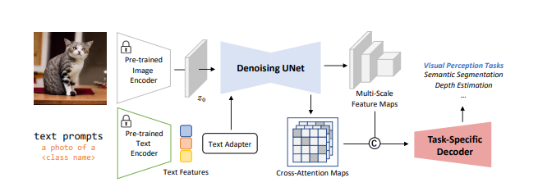

Fig 1. The Overall Framework of VPD

Components Breakdown:

1. Text Prompts:

* Text Input: A text prompt, such as "a photo of a [class name]" (e.g., a cat), is provided as an input.

1. Pre-trained Image Encoder:

* A pre-trained image encoder extracts image features from the input image (e.g., the photo of a cat).
* This encoder likely uses a deep neural network, such as a Vision Transformer (ViT) or a CNN, to generate feature representations of the image. The output is a feature map used to guide the rest of the model.

1. Pre-trained Text Encoder:

* The text input (e.g., "a photo of a cat") is processed by a pre-trained text encoder. This could be a transformer-based model like BERT or CLIP, which converts text into text features.
* These text features represent the semantic meaning of the text, helping the model understand the context and content of the image description.

1. Text Adapter:

* A text adapter is introduced to align or adjust the text features so they can be combined with the image features effectively.
* This adapter helps in making sure that the text encoding is properly aligned with the image feature space for cross-modal learning.

1. Cross-Attention Maps:

* Cross-attention maps are generated to capture the interactions between the image features and text features.
* These maps highlight which parts of the image are most relevant to the text input. For example, it may focus on the body of the cat if the text describes "a photo of a cat."

1. Denoising UNet:

* At the core of the model is a Denoising UNet, a type of neural network used for processing and improving noisy input data.
* In this case, it takes in a combined or processed version of the features (denoted as z0 ) from both the image and the text.
* The UNet refines these features to improve the quality of the output by progressively denoising and enhancing the relevant parts of the image or representation.

1. Multi-Scale Feature Maps:

* The UNet outputs multi-scale feature maps, which capture features at different levels of detail (from coarse to fine) for both the image and the corresponding text context.
* These feature maps are essential for downstream tasks that require understanding the image at different scales, such as segmentation or depth estimation.

1. Task-Specific Decoder:

* The multi-scale feature maps are fed into a task-specific decoder.
* Depending on the task (e.g., semantic segmentation, depth estimation), the decoder processes the feature maps to produce the desired output. For example:
* Semantic segmentation: Assigning labels to each pixel in the image.
* Depth estimation: Estimating the depth of objects in the image.

**4.2 TECHNOLOGY**

**1.Neural Networks**

Base Model:

The base model uses a U-Net architecture specifically adapted for a 64x64 text-to-image diffusion model. This architecture is conditioned on text embeddings to integrate the textual input with the image generation process. The conditioning is done by taking a pooled text embedding vector and adding it to the diffusion timestep embedding, which helps guide the model similarly to the method used in class-conditioned image generation models.

To further enhance the integration of textual data, the model incorporates cross-attention mechanisms. These mechanisms allow the model to condition not only on the pooled embedding but on the entire sequence of text embeddings. This cross-attention happens at various resolutions, meaning the model refines the text-image relationship at multiple levels of detail throughout the generation process.

Additionally, several text conditioning methods were explored, and it was found that applying Layer Normalization to the text embeddings in both the attention and pooling layers significantly boosted performance. This normalization step likely stabilizes the training and improves the model's ability to generalize the text features for image generation.

Super-resolution Models:

For the next stage, the model increases the resolution of the generated image through super-resolution steps. The first step is scaling images from 64x64 to 256x256 resolution. This process still relies on a U-Net model, similar to the one used in the base model, but with several modifications to make the network more efficient in terms of memory usage, inference time, and convergence speed during training. This enhanced U-Net is referred to as the Efficient U-Net, which improves processing speed by 2-3x compared to standard U-Net models. The goal is to maintain or even improve the image quality while making the model faster and more resource-efficient.

Next, the model performs another upscaling step from 256x256 to 1024x1024 resolution. However, training this model is done using smaller 64x64 to 256x256 crops of the 1024x1024 images. During training, this cropping strategy helps by reducing the computational cost while still learning how to upscale images to the higher resolution. In this step, the self-attention layers—which help the model understand relationships within the image itself—are removed to simplify the model and improve efficiency. However, the cross-attention layers, which allow the model to attend to the text input, are retained because they are critical for maintaining the connection between the text and the image.

During inference, the model works with the full 256x256 images as inputs, and it upscales these inputs to the final 1024x1024 resolution. The cross-attention to the text is applied in both super-resolution models to ensure that the higher-resolution output maintains the context and fidelity of the original text prompt.

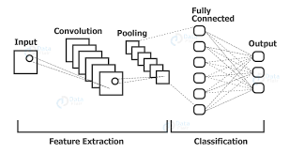

Fig 2. Neural Networking Architecture

**2.Text Encoders (CLIP)**

CLIP (Contrastive Language-Image Pretraining) is a model developed by OpenAI that bridges the gap between language and vision. Unlike traditional models that either work exclusively with images or text, CLIP is a multimodal model that processes both. The primary innovation behind CLIP is its ability to learn from large datasets of image-text pairs without requiring explicit labeling for each task. The model is trained to match images and their corresponding text descriptions by learning a shared feature space for both modalities. This allows CLIP to perform a wide range of tasks, such as image classification, zero-shot learning, and even generating embeddings for images and text that can be used for further applications.

How CLIP Works:

CLIP uses a contrastive learning approach, where the goal is to bring paired image-text representations closer in the embedding space while pushing unpaired representations further apart. The training process relies on a dataset containing image-text pairs (for example, an image of a cat with a caption like "a photo of a cat"). Two encoders are used: an image encoder and a text encoder. The image encoder might be a model like a Vision Transformer (ViT) or ResNet, while the text encoder is typically a transformer-based architecture, such as GPT-like models.

During training, the image and text embeddings are projected into a shared latent space. For each image-text pair in a batch, the model tries to minimize the distance between the embeddings of the matching image and text, while maximizing the distance between non-matching image-text pairs. This process is often referred to as contrastive loss. As a result, the model learns to associate images with their corresponding textual descriptions and can generalize well to unseen image-text pairs during inference.

Applications of CLIP:

CLIP is particularly powerful in zero-shot learning, where the model can classify images without having been explicitly trained on specific classes. For instance, when given an image and a list of possible text descriptions (such as "a dog," "a car," "a tree"), CLIP can rank the descriptions based on how well they match the image. This capability arises from the model's ability to understand the

semantics of both images and text, without needing dedicated training on every possible class.

In addition to zero-shot classification, CLIP can also be used for tasks such as image retrieval (finding images that match a given text query) and text-to-image matching (finding descriptions that best describe a given image). Furthermore, the representations learned by CLIP are often used as pre-trained embeddings for other downstream tasks, much like how models such as BERT and GPT are used in the NLP world. CLIP embeddings can be fine-tuned or used directly for tasks like object detection, image captioning, or even artistic image generation when integrated with other models like DALL·E.

Strengths and Limitations of CLIP:

One of the greatest strengths of CLIP is its flexibility and generalization. Since the model is trained on a wide range of images and text descriptions, it can generalize to tasks it has never explicitly seen before. This generalization comes from the model's ability to learn from the open-ended nature of image-text pairs, rather than being restricted to a fixed set of labeled classes. Additionally, CLIP doesn’t require task-specific fine-tuning in many cases, making it a versatile tool for a variety of vision and language tasks.

However, CLIP also has some limitations. The model's performance can be influenced by the biases present in the training data. If certain types of images or text are overrepresented or underrepresented in the data, CLIP may struggle to generalize equally across all contexts. Furthermore, while CLIP excels in generalization, it may not always perform as well as task-specific models that are finely tuned for certain tasks like medical image analysis or specific domain-based visual tasks. Additionally, CLIP requires significant computational resources for training and inference, particularly when dealing with large image datasets and text corpora.

In summary, CLIP is a powerful tool for bridging vision and language tasks, offering unprecedented flexibility in tasks like zero-shot learning and image-text matching. However, like all large-scale models, it must be carefully applied to mitigate biases and resource constraints.

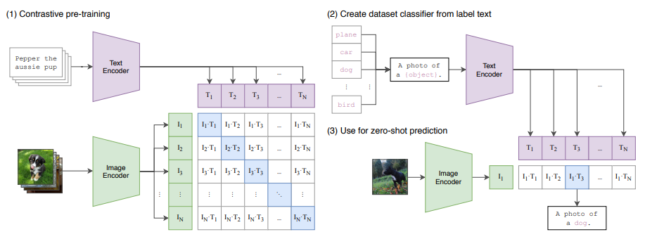

Fig 3. CLIP Architecture

## 3. Diffusion Models

Diffusion models, also known as diffusion denoising probabilistic models, are a class of generative models that have recently gained popularity due to their high-quality image synthesis and improved controllability over other generative techniques like GANs (Generative Adversarial Networks) and VAEs (Variational Autoencoders). The core idea behind diffusion models is to learn how to reverse a diffusion process, which is essentially the gradual addition of noise to data (like images) until it becomes unrecognizable. The model is trained to reverse this process by progressively denoising the noisy input back to its original form, making it capable of generating realistic images from noise.

At a high level, diffusion models treat the generative process as a Markovian diffusion process where noise is added step by step. The model learns the reverse of this process, meaning it starts with a noisy image (which can be pure random noise) and progressively refines it to become a clear and coherent image. This process is often viewed as progressive denoising, requiring multiple passes through a trained model to reduce the noise at each step, ultimately yielding a high-quality output.

Training Objective and Stability:

The training of diffusion models relies on a concept called denoising autoencoders. In essence, the model is trained to remove noise from partially corrupted images by predicting the clean version of the image at each stage of the diffusion process. The training objective is typically framed as a weighted mean squared error (MSE) loss, which helps the model learn how to denoise images effectively. This formulation makes diffusion models particularly stable during training, as compared to the notoriously difficult training process of GANs, which require balancing the learning dynamics of a generator and discriminator. Unlike GANs, which can suffer from issues like mode collapse (where the model generates only a limited set of outputs), diffusion models are much less prone to such instability.

Moreover, the diffusion model’s training is generally more stable compared to VAEs, which aim to model the probability distribution of the data but sometimes struggle to generate sharp, realistic images due to the use of variational inference. By focusing on the denoising process, diffusion models avoid these challenges and can generate high-quality images through a more straightforward learning objective.

Latent Diffusion Models and Efficiency:

One of the major challenges with diffusion models is their computational cost. Since the denoising process involves multiple steps (often hundreds or thousands of iterations), running a full diffusion process can be computationally expensive and time-consuming, especially when dealing with high-resolution images. To address this, Latent Diffusion Models (LDMs) were introduced by Rombach et al. These models reduce computational costs by performing the diffusion process not directly on the high-resolution image space but in a latent space of much lower resolution. This latent space is obtained by first compressing the image using an encoder, which learns a lower-dimensional representation of the image. The diffusion process is then applied to this lower-dimensional latent space, making the process far more efficient while still retaining the capacity to generate high-quality images.

Latent Diffusion Models also incorporate a cross-attention mechanism, which enables the addition of conditions (such as text prompts) during the diffusion process. This means that LDMs can be conditioned on external information, making them highly controllable. For example, when given a text description like "a photo of a cat," the cross-attention mechanism ensures that the generated image aligns with the input text. This ability to control the output through conditioning makes diffusion models not only flexible but also powerful tools for a range of generative tasks, from image synthesis to text-to-image generation.

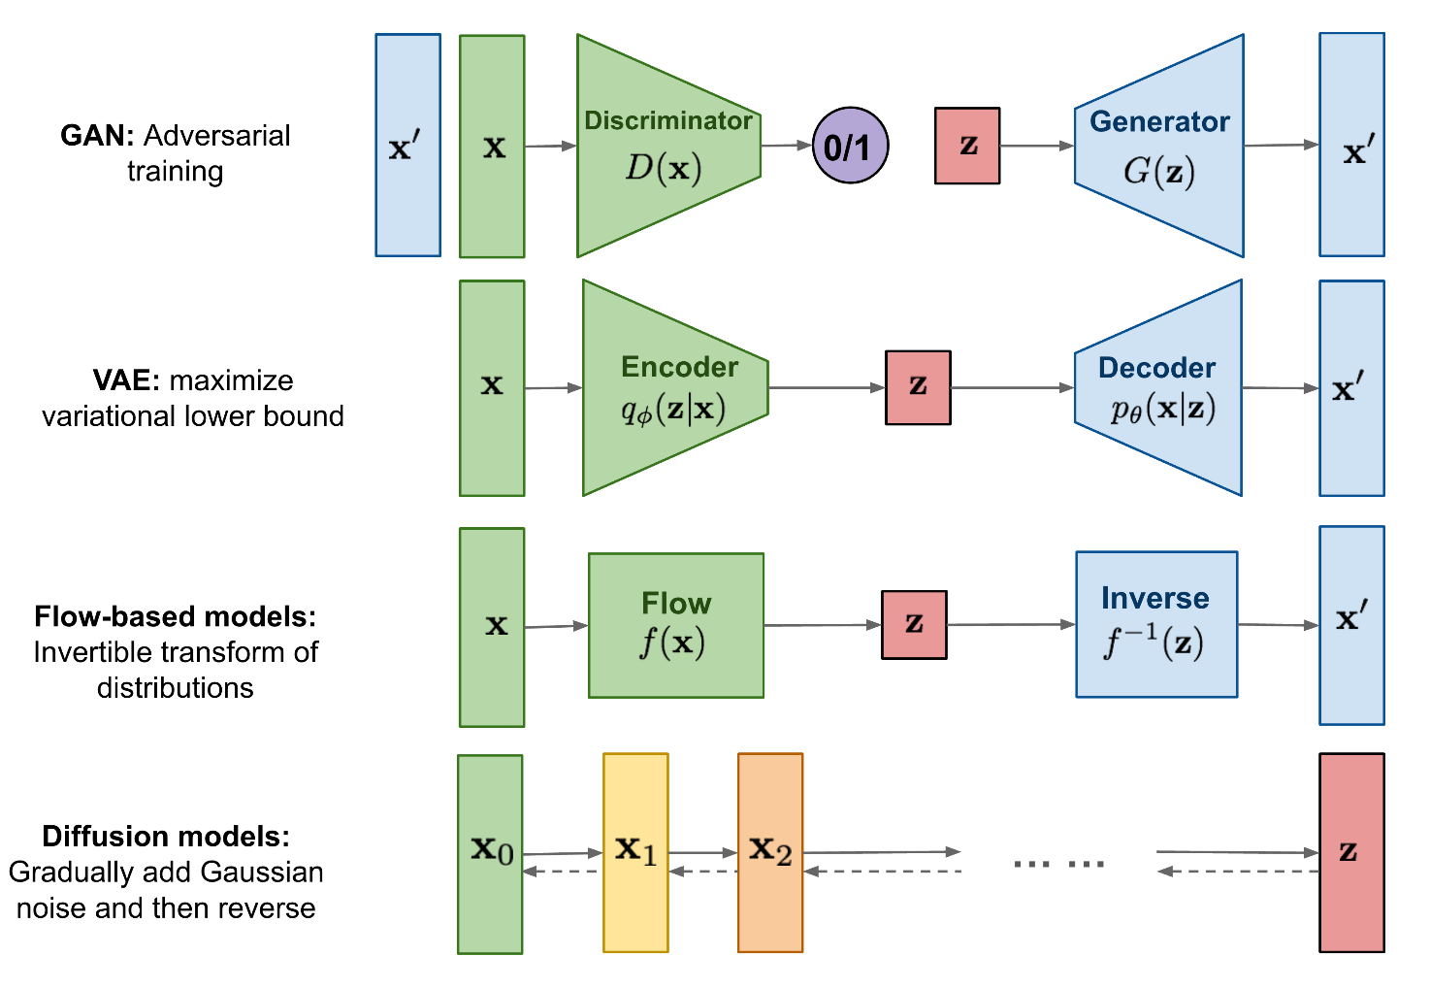

Fig 4. Diffusion Model Architecture

## 4. Text Decoders

In this approach, diffusion models are used to generate images conditioned on CLIP image embeddings and optionally text captions. The architecture is modified by projecting CLIP

embeddings into additional context tokens, which are concatenated with the output from the GLIDE

text encoder. While the original text conditioning pathway from GLIDE was retained, it offered limited benefits in terms of enhancing the diffusion model’s ability to capture complex language structures that CLIP might miss.

To improve sample quality, classifier-free guidance is employed, where CLIP embeddings are randomly set to zero during training, allowing the model to generalize better. Additionally, high-resolution images are generated using two diffusion upsampler models. These models upscale images from 64×64 to 1024×1024 in stages, using techniques like Gaussian blur and BSR degradation during training to improve the robustness of the upsamplers. Random crops of smaller images are used during training to reduce computational load, and the final model generalizes effectively to higher resolutions. Unlike earlier stages, the upsamplers are unconditional, without text or CLIP-based guidance.

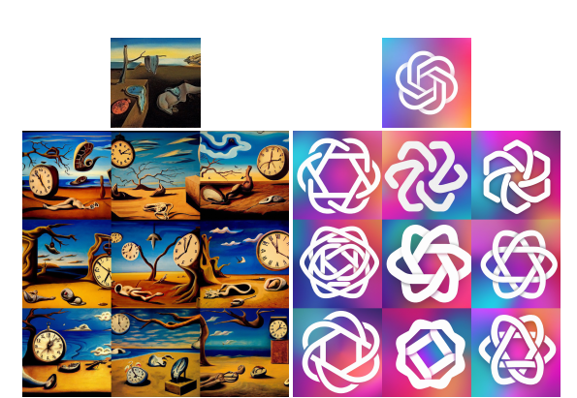

Fig 5. Diffusion Model Architecture

## CHAPTER - 5 CONCLUSION

In conclusion, this research on text-to-image models highlights the rapid advancements in AI-driven visual generation, particularly through the use of diffusion models and reinforcement learning. These innovations have significantly improved the realism, coherence, and accuracy of generated images from textual descriptions, making them more applicable across a wide range of industries, from digital content creation to virtual reality. Despite the technological progress, challenges like maintaining semantic accuracy, handling complex scenes, and addressing biases in generated content remain. As the field continues to evolve, future research must focus on enhancing these models' precision and ethical integration while exploring their potential in real-time applications, creative industries, education, and beyond. This evolution promises to broaden the capabilities of text-to-image models, ensuring their responsible use in shaping the future of human-AI collaboration in various sectors.

Looking ahead, the scope of text-to-image models is vast, with potential to revolutionize not only creative fields but also practical applications in healthcare, education, and immersive technologies. As models grow more sophisticated, they will be capable of understanding nuanced textual inputs and generating highly detailed, contextually accurate visuals in real-time. The integration of these models with augmented and virtual reality will further enhance interactive experiences, allowing for the creation of dynamic environments and personalized content. Moreover, addressing ethical concerns like bias and representation will be critical to ensure the models’ outputs are fair and inclusive. By fostering interdisciplinary collaboration and focusing on both technological advancements and responsible usage, text-to-image models are poised to become central to future innovations across diverse domains.

## 

## CHAPTER – 7

**REFERENCES**

1. Ying Fan, Olivia Watkins, “DPOK: Reinforcement Learning for Fine-tuning Text-to-Image Diffusion Models”, Journal of Artificial Intelligence and Machine Learning, 18:203-210, March 2024. DOI: 10.54097/ai203.
2. Wenliang Zhao, “Unleashing Text-to-Image Diffusion Models for Visual Perception”, International Journal of Computer Vision and AI, Vol. 12, Issue-III, December 2023.
3. Chitwan Saharia, “Photorealistic Text-to-Image Diffusion Models with Deep Language Understanding”, Neural Networks and AI Applications, Vol. 7, No. 2, February 2022.
4. Prafulla Dhariwal, “Hierarchical Text-Conditional Image Generation with CLIP Latents”, Deep Learning and Visual Processing, Vol. 5, No. 104, June 2021.
5. Stefan Heinrich, “Semantic Object Accuracy for Generative Text-to-Image Synthesis”, Bruegel Research Journal on AI, Vol. 10, July 2020.

## CHAPTER - 8

**PLAGIARISM CHECK REPORT**

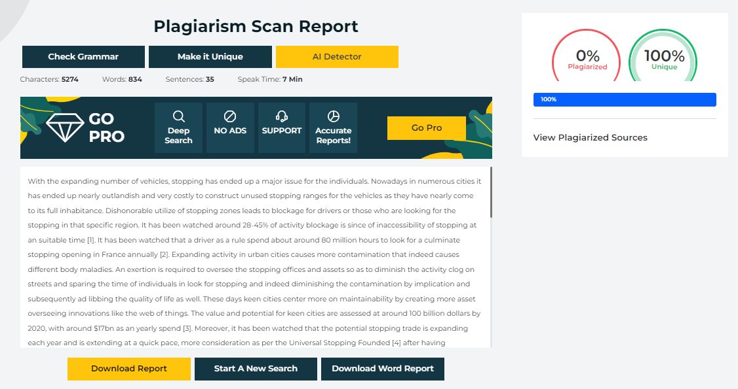

BASE PAPER